Student Name: __________________________________________________
Parent Signature: _______________________________________________
Notes or comments:
__________________________________________________________________________________________________________________________________________________________________________________________________________________________________________________________________________________________________________________________________________________________________________________________________________________________________________________________________________________________________________
This is where you will find a list of spelling words for the week. It will be your child’s responsibility to practice their spelling words and be ready to take a test on Fridays.

We will not start spelling lists until the week of August 19th.
In this section you will find your child’s assessment scores. Please see the attached document for an explanation of the assessments your child will be taking throughout the year.

Evaluate:

Previous month’s score: ______________
Current month’s score: _______________
Growth: __________

Lexile Score: _____________
Goal: TBD

SRI Level: ________________
Goal: TBD

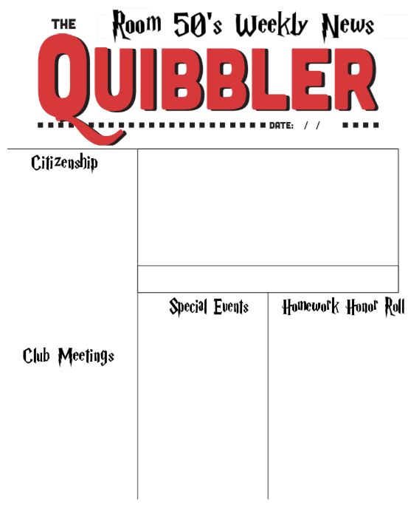

Arreee You Ready for the Ultimate Learning Adventure?!
WELCOME TO 5th Grade!
I am Mrs. Wilber, and I am so excited to have the opportunity to be your child’s 5th grade teacher. This newsletter will be sent home with your child every Friday. This newsletter will contain information about upcoming events, club meetings, homework honor roll, student behavior notes, student test scores, and spelling words for the week. Please look over this newsletter each week with your child, sign it, then send it back to school with your child on Monday.

Kwilber@perryschools.org (317) 789-3339
This is where you will find a list of clubs that will be meeting before or after school each week. A few of the clubs that are offered here at SES are;
-Robotics Team
-Sprouts Club
-Service Club
-Spell Bowl
-Math Bowl
-Sprinters Club
-Religious Education

There are no club meetings the first week of school. Clubs will start up in a couple of weeks!
Wednesday July 23rd
First Student Day

If your child turns in their homework each day and on time, they will receive a homework honor roll prize. If students do not complete a homework assignment, they may be asked to say in for recess to complete an assignment.

